Nama : Frederico Steven Kwok
NPM : 242310037
Kelas : TI-24-PA1
Mata Kuliah : Lab. Pemrograman Web
Tugas : Pertemuan 7 – Tugas dan Latihan 6
Github : https://github.com/RicoSteven120206/PW-MERN-STACK-242310037.git
Dokumentasi Lengkap Source Code Berada di Repository Github
- Lengkapi sistem backend dengan modul manajemen pengguna (User Management). Modul ini akan menangani data pengguna yang nantinya akan berinteraksi dengan koleksi buku. Dengan ketentuan seperti dibawah ini:
- Buatlah model yang merepresentasikan table users dengan attribute seperti table users dibawah ini:
Source Code pada model tabel users /models/User.js
"use strict";
const { Model } = require("sequelize");

module.exports = (sequelize, DataTypes) => {
class User extends Model {
/**
* Helper method for defining associations.
* This method is not a part of Sequelize lifecycle.
* The `models/index` file will call this method automatically.
*/
static associate(models) {
// define association here
// contoh: User.hasMany(models.Book, { foreignKey: "user_id" });
}
}

User.init(
{
email: {
type: DataTypes.STRING(100),
allowNull: true,
},
username: {
type: DataTypes.STRING(50),
allowNull: true,
},
password: {
type: DataTypes.STRING(255),
allowNull: true,
},
is_active: {
type: DataTypes.BOOLEAN, // tinyint(1) di MySQL dipetakan ke BOOLEAN
allowNull: true,
},
},
{
sequelize,
modelName: "User",
tableName: "users",
timestamps: true, // otomatis kelola createdAt & updatedAt
}
);

return User;
};

- Jalankan migrasi untuk memastikan table users terbentuk dengan benar di database.
Untuk membuat isi file nya di migration dengan mengetik dibawah berikut, setelah itu isi migration pada source code dibawah.
npx sequelize-cli migration:generate --name create-books

Source Code untuk migration 20260611023601-create-books
"use strict";
module.exports = {
async up(queryInterface, Sequelize) {
await queryInterface.createTable("users", {
id: {
allowNull: false,
autoIncrement: true,
primaryKey: true,
type: Sequelize.INTEGER,
},
email: {
type: Sequelize.STRING(100),
allowNull: true,
},
username: {
type: Sequelize.STRING(50),
allowNull: true,
},
password: {
type: Sequelize.STRING(255),
allowNull: true,
},
is_active: {
type: Sequelize.BOOLEAN,
allowNull: true,
},
createdAt: {
allowNull: false,
type: Sequelize.DATE,
},
updatedAt: {
allowNull: false,
type: Sequelize.DATE,
},
});
},

async down(queryInterface, Sequelize) {
await queryInterface.dropTable("users");
},
};
Untuk menjalankan migration nya seperti berikut.
npx sequelize-cli db:migrate
Akan nampilkan Output jika berhasil
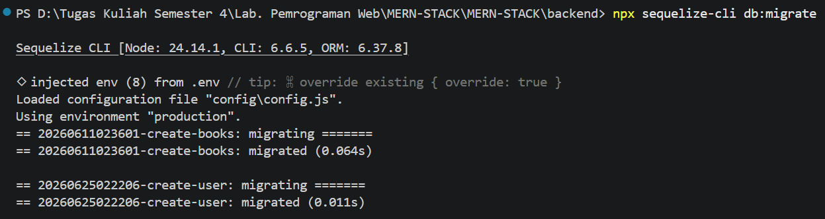
- Buatkan routing rest api untuk user management seperti table dibawah ini:
Method | Endpoint | Controller Action | Keterangan
GET | / | getAllUsers | Mengambil daftar semua user.
GET | /:id | getUserById | Mengambil detail user  berdasarkan ID unik.
POST | / | createUser | Menambah data user baru.
PUT | /:id | updateUser | Memperbarui seluruh data user.
DELETE | /:id | deleteUser | Menghapus user berdasarkan ID.

- Source Code pada membangun Controller dan Routes
Source Code pada UserController.js
const db = require("../models");
const User = db.User;
const { Op } = db.Sequelize;
const bcrypt = require("bcrypt");
const jwt = require("jsonwebtoken");

// Login users
exports.loginUser = async (req, res) => {
try {
const { email, password } = req.body;

if (!email || !password) {
return res.status(400).json({
success: false,
message: "Email and password are required",
});
}

// Find user by email
const user = await User.findOne({ where: { email } });
if (!user) {
return res.status(401).json({
success: false,
message: "Invalid email or password",
});
}

// Check if user is active
if (!user.is_active) {
return res.status(403).json({
success: false,
message: "Account is inactive. Please contact administrator",
});
}

// Verify password
const isPasswordValid = await bcrypt.compare(password, user.password);
if (!isPasswordValid) {
return res.status(401).json({
success: false,
message: "Invalid email or password",
});
}

const userResponse = {
id: user.id,
email: user.email,
username: user.username,
};

const expirationTime = Math.floor(Date.now() / 1000) + 6 * 60 * 60;
const accessToken = jwt.sign(userResponse, process.env.JWT_SECRET, {
expiresIn: "6h",
});

res.json({
success: true,
message: "Login successful",
data: userResponse,
accessToken,
expiresIn: expirationTime,
});
} catch (error) {
console.error("Error during login:", error);
res.status(500).json({
success: false,
message: "Failed to login",
error: error.message,
});
}
};

// Get all users
exports.getAllUsers = async (req, res) => {
try {
const { search, is_active, sort_by, order } = req.query;

// Build where clause
let whereClause = {};

if (search) {
whereClause = {
...whereClause,
[Op.or]: [
{ username: { [Op.like]: `%${search}%` } },
{ email: { [Op.like]: `%${search}%` } },
],
};
}

if (is_active !== undefined) {
whereClause.is_active = is_active === "true";
}

// Build order clause
let orderClause = [["created_at", "DESC"]];
if (sort_by) {
const sortOrder = order && order.toUpperCase() === "ASC" ? "ASC" : "DESC";
orderClause = [[sort_by, sortOrder]];
}

const users = await User.findAll({
where: whereClause,
order: orderClause,
attributes: { exclude: ["password"] }, // Exclude password from response
});

res.json({
success: true,
count: users.length,
data: users,
});
} catch (error) {
console.error("Error fetching users:", error);
res.status(500).json({
success: false,
message: "Failed to fetch users",
error: error.message,
});
}
};

// Get single user by ID
exports.getUserById = async (req, res) => {
try {
const user = await User.findByPk(req.params.id, {
attributes: { exclude: ["password"] },
});

if (!user) {
return res.status(404).json({
success: false,
message: "User not found",
});
}

res.json({
success: true,
data: user,
});
} catch (error) {
console.error("Error fetching user:", error);
res.status(500).json({
success: false,
message: "Failed to fetch user",
error: error.message,
});
}
};

// Create new user (Register)
exports.createUser = async (req, res) => {
try {
const { email, username, password, is_active } = req.body;

// Validation
if (!email || !username || !password) {
return res.status(400).json({
success: false,
message: "Email, username, and password are required",
});
}

// Check if email already exists
const existingEmail = await User.findOne({ where: { email } });
if (existingEmail) {
return res.status(400).json({
success: false,
message: "Email already exists",
});
}

// Check if username already exists
const existingUsername = await User.findOne({ where: { username } });
if (existingUsername) {
return res.status(400).json({
success: false,
message: "Username already exists",
});
}

// Hash password
const saltRounds = 10;
const hashedPassword = await bcrypt.hash(password, saltRounds);

// Create user
const user = await User.create({
email,
username,
password: hashedPassword,
is_active: is_active !== undefined ? is_active : true,
});

// Remove password from response
const userResponse = user.toJSON();
delete userResponse.password;

res.status(201).json({
success: true,
message: "User created successfully",
data: userResponse,
});
} catch (error) {
console.error("Error creating user:", error);

// Handle validation errors
if (error.name === "SequelizeValidationError") {
return res.status(400).json({
success: false,
message: "Validation error",
errors: error.errors.map((e) => ({
field: e.path,
message: e.message,
})),
});
}

res.status(500).json({
success: false,
message: "Failed to create user",
error: error.message,
});
}
};

// Update user (full update)
exports.updateUser = async (req, res) => {
try {
const user = await User.findByPk(req.params.id);

if (!user) {
return res.status(404).json({
success: false,
message: "User not found",
});
}

const { email, username, password, is_active } = req.body;

// Check if email is being changed and already exists
if (email && email !== user.email) {
const existingEmail = await User.findOne({ where: { email } });
if (existingEmail) {
return res.status(400).json({
success: false,
message: "Email already exists",
});
}
}

// Check if username is being changed and already exists
if (username && username !== user.username) {
const existingUsername = await User.findOne({ where: { username } });
if (existingUsername) {
return res.status(400).json({
success: false,
message: "Username already exists",
});
}
}

// Prepare update data
const updateData = {
email: email || user.email,
username: username || user.username,
is_active: is_active !== undefined ? is_active : user.is_active,
};

// Hash new password if provided
if (password) {
const saltRounds = 10;
updateData.password = await bcrypt.hash(password, saltRounds);
}

await user.update(updateData);

// Remove password from response
const userResponse = user.toJSON();
delete userResponse.password;

res.json({
success: true,
message: "User updated successfully",
data: userResponse,
});
} catch (error) {
console.error("Error updating user:", error);

// Handle validation errors
if (error.name === "SequelizeValidationError") {
return res.status(400).json({
success: false,
message: "Validation error",
errors: error.errors.map((e) => ({
field: e.path,
message: e.message,
})),
});
}

res.status(500).json({
success: false,
message: "Failed to update user",
error: error.message,
});
}
};

// Patch user (partial update)
exports.patchUser = async (req, res) => {
try {
const user = await User.findByPk(req.params.id);

if (!user) {
return res.status(404).json({
success: false,
message: "User not found",
});
}

const { email, username, password, is_active } = req.body;

// Check if email is being changed and already exists
if (email && email !== user.email) {
const existingEmail = await User.findOne({ where: { email } });
if (existingEmail) {
return res.status(400).json({
success: false,
message: "Email already exists",
});
}
}

// Check if username is being changed and already exists
if (username && username !== user.username) {
const existingUsername = await User.findOne({ where: { username } });
if (existingUsername) {
return res.status(400).json({
success: false,
message: "Username already exists",
});
}
}

// Prepare update data
const updateData = { ...req.body };

// Hash new password if provided
if (password) {
const saltRounds = 10;
updateData.password = await bcrypt.hash(password, saltRounds);
}

await user.update(updateData);

// Remove password from response
const userResponse = user.toJSON();
delete userResponse.password;

res.json({
success: true,
message: "User updated successfully",
data: userResponse,
});
} catch (error) {
console.error("Error updating user:", error);

if (error.name === "SequelizeValidationError") {
return res.status(400).json({
success: false,
message: "Validation error",
errors: error.errors.map((e) => ({
field: e.path,
message: e.message,
})),
});
}

res.status(500).json({
success: false,
message: "Failed to update user",
error: error.message,
});
}
};

// Delete user
exports.deleteUser = async (req, res) => {
try {
const user = await User.findByPk(req.params.id);

if (!user) {
return res.status(404).json({
success: false,
message: "User not found",
});
}

await user.destroy();

res.json({
success: true,
message: "User deleted successfully",
});
} catch (error) {
console.error("Error deleting user:", error);
res.status(500).json({
success: false,
message: "Failed to delete user",
error: error.message,
});
}
};

Source Code pada UserRoutes.js
const express = require("express");
const router = express.Router();
const userController = require("../controllers/userController");
const { verifyToken } = require('../middleware/auth');

router.post('/login', userController.loginUser);
router.post('/register', userController.createUser);

router.use(verifyToken);

router.get("/", userController.getAllUsers);
router.get("/:id", userController.getUserById);
router.post("/", userController.createUser);
router.put("/:id", userController.updateUser);
router.patch("/:id", userController.patchUser);
router.delete("/:id", userController.deleteUser);

module.exports = router;

- Lakukan pengujian menggunakan aplikasi penguji API (seperti Postman atau Insomnia) untuk memastikan bahwa setiap endpoint mengembalikan status kode HTTP yang benar (Contoh: 200 untuk sukses, 201 untuk data baru, 404 jika user tidak ditemukan).
- Screenshot pengujian HTTP Status Code
Status Code HTTP 201 – Register => POST api/users/register
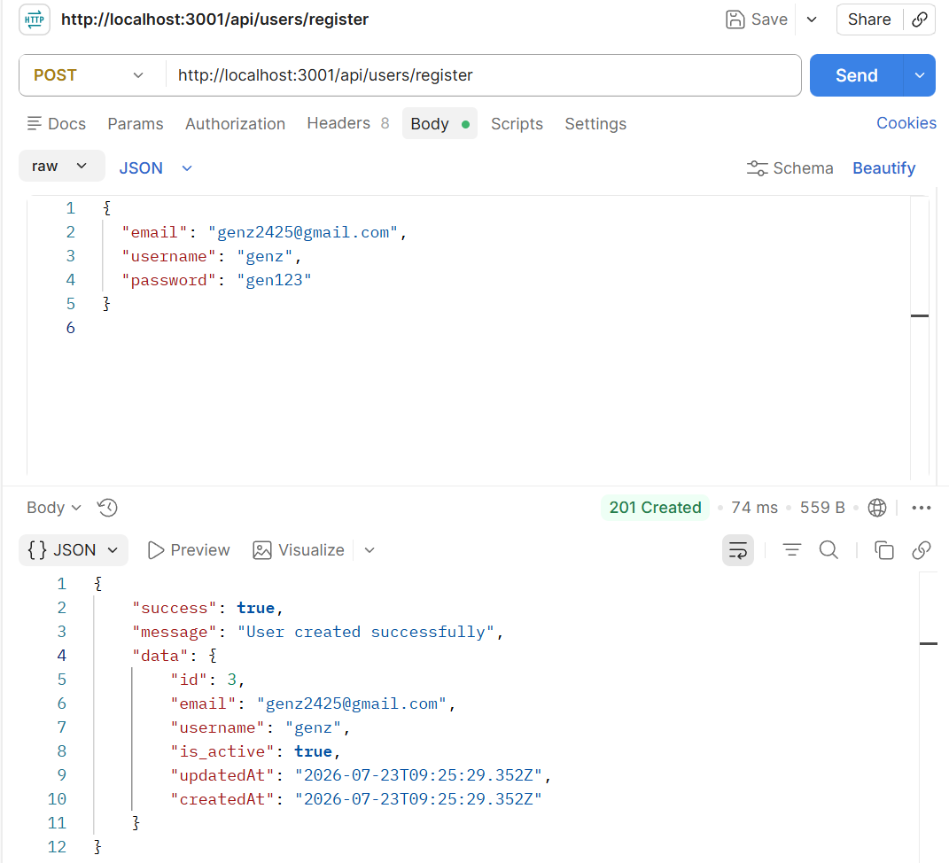

Status Code HTTP 200 – Login => POST api/users/login
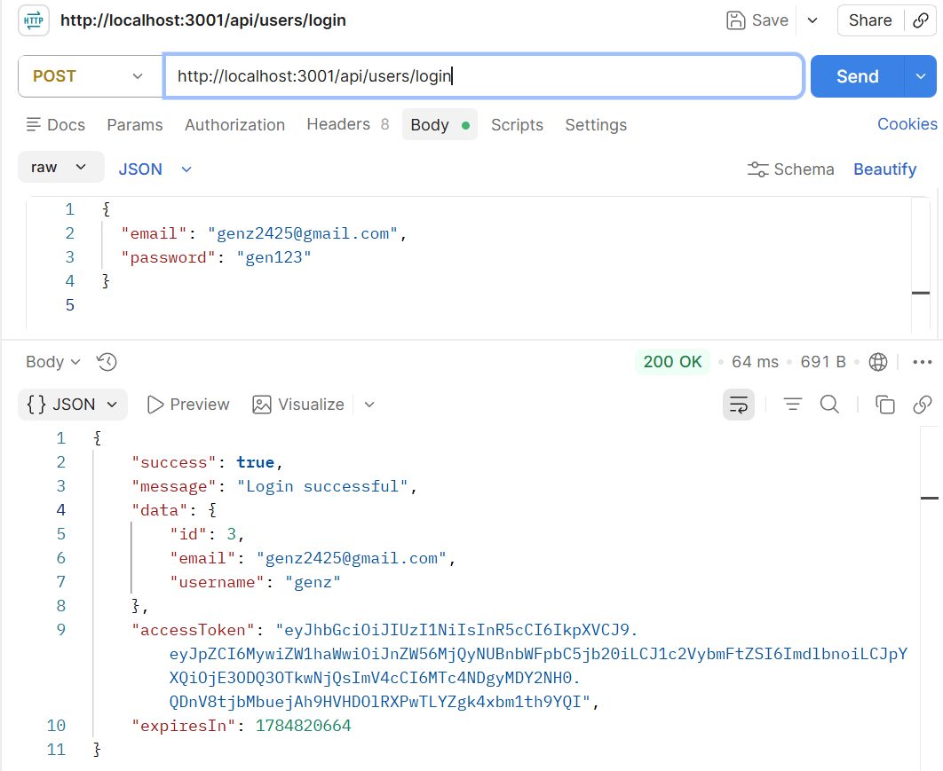
Status Code HTTP 400 – Request Buruk disebabkan ada Field kosong atau tidak sesuai
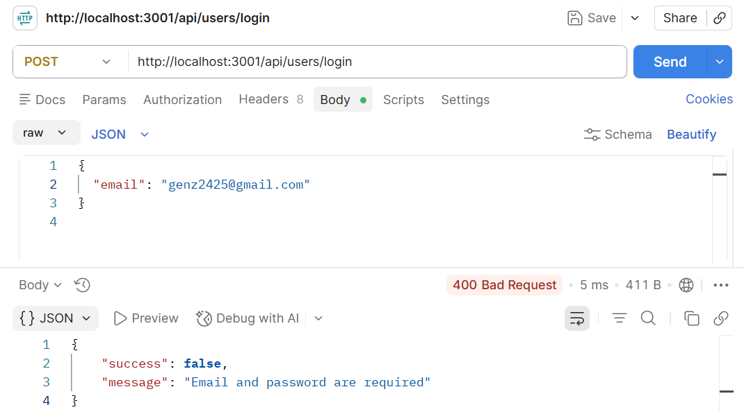
Status Code HTTP 401 – Unauthorized disebabkan karena tidak sesuai terdaftar atau field tidak sama.
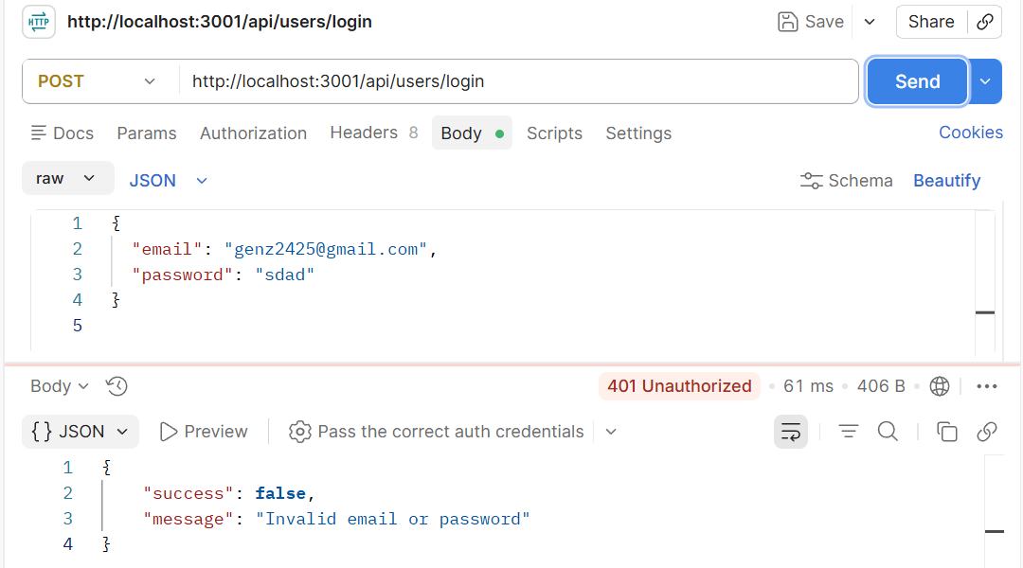
Status Code 403 – Forbidden disebabkan karena Token Palsu
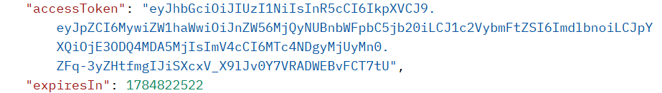
Biasanya akan gagal untuk mendapatkan akses.
Status | Kapan Muncul atau Terjadi
200 OK | Berhasil GET/PUT/PATCH/DELETE
201 Created | Berhasil Register/Create User
400 Bad Request | Field wajib kosong, email/username duplikat
401 Unauthorized | Login gagal, atau tidak kirim token sama sekali
403 Forbidden | Token ada tapi tidak valid/rusak, atau akun nonaktif
404 Not Found | ID user tidak ditemukan

- Buatlah dokumentasi dalam mengerjakan soal Latihan Pembelajaran soal nomor 1-3, dengan memberikan Screenshot baik dari sisi aplikasi ataupun code yang sudah dimodifikasi dengan penjelasan dan alur yang baik dan benar. Dokumentasi disimpan dalam bentuk PDF dan ditaruh dalam project web yang telah anda kerjakan.
- Done. Pengerjaan Dokumentasi Selesai.
- Upload project tersebut pada GITHUB dengan menggunakan repository bernama "PW-MERN-STACK-NPM" dengan nama commit “Praktikum 7”.
Link GITHUB PW-MERN-STACK-242310037
https://github.com/RicoSteven120206/PW-MERN-STACK-242310037.git

